
9
SPEAR

Surveying and Planning through Electronic Applications and Referrals



SPEAR Release Notes

Release 5.14

The following functional changes to SPEAR have been included in Release 5.14:
 | Users Impacted | Feature | Description
 | Applicant Contacts | Phase out Visualisation Enhancement Tool (VET) and allow surveyors to provide PDF plans.  - CR 5859 | The following changes have been made to SPEAR to support the phase out of the Visualisation Enhancement Tool (VET) for ePlans:  - SPEAR will no longer visualise a PDF plan when an ePlan is attached to a SPEAR application. Instead, a PDF plan must be uploaded/saved in the ePlan Portal, and will be retrieved and used in SPEAR.  Note: Until further notice, the VET will continue to be available for ePlans that exist at the time of this release. All newly created ePlans must be supported by a PDF plan created outside of the ePlan Portal by the surveyor. Any new versions of the PDF plan must be added through the ePlan Portal, even if the digital data is not changing.  - A new ‘Add/Update ePlan’ action has been introduced to allow applicant contacts to supply an updated ePlan which includes the required survey information after certification.  For ePlan applications, this action will appear in SPEAR once a Statement of Compliance is issued. It can also be completed optionally once the plan is certified. For PDF applications, it will appear as an optional action to allow users to attach an ePlan.  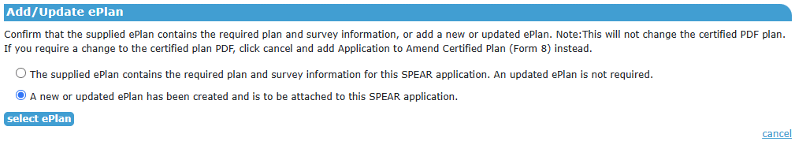  Applicant contacts will need to indicate whether the existing certified ePlan already includes all required survey information, or alternatively attach an updated ePlan file that has been saved in the ePlan Portal.  A re-certification will not be required to update an ePlan which is adding or changing survey data to be consistent with any PDF survey documents, however if a change is required to the certified PDF plan, then an application to amend a certified plan must be created instead.  Note: The certified PDF plan in SPEAR will be copied against the selected ePlan version when the 'Add/Update ePlan' action is used. This will replace any newer PDF plan uploaded to the ePlan Portal for the selected ePlan version, ensuring the certified PDF plan can be accessed from both systems.  - Applicant contacts will need to make a declaration that the digital data in the ePlan is consistent with the PDF plan and/or survey documents at the following points:  - When submitting the application to the Responsible Authority, for certification and joint planning permit and certification applications  - When releasing for lodgement for certification and joint planning permit and certification  - When submitting for pre-lodgement check, for electronically lodged boundary plan applications  - When uploading a plan which has been requisitioned by Land Use Victoria, for certification, joint certification and planning permit, and boundary plan applications.

